FOREIGN EXCHANGE (FX)
Pricing, Parity, and Trading the World's Largest Financial Market
From Spot Quotes and Parity Conditions to Carry, Momentum, and Real-World Crises
A Level 2 module in the Quantitative Finance Curriculum
Covers: currency pairs & market structure · purchasing power parity · covered & uncovered interest rate parity · forwards, futures, swaps & options · the carry trade · FX momentum & value strategies · central bank intervention · hedging · volatility & tail risk · real-world crises from Black Wednesday to the SNB shock

Table of Contents
How to Use This Guide
What You Need to Know Before Starting
Understand Before Proceeding
Why It Matters
How This Connects to the Rest of the Curriculum
Glossary of Recurring Terms
Part 1 — Foundations of the FX Market
1.1 What Is FX? Currency Pairs, Quotes, and Market Structure
1.2 Who Trades FX, and Why
1.3 Spot Trades and the Mechanics of Settlement
Part 2 — FX Pricing: Parity Conditions and Fair Value
2.1 Purchasing Power Parity
2.2 Interest Rate Parity and Forward Pricing
2.3 The Carry Trade: Trading the Deviation from UIP
Part 3 — FX Derivatives: Forwards, Futures, Swaps, and Options
3.1 Outright Forwards and FX Swaps
3.2 Currency Futures and Non-Deliverable Forwards
3.3 FX Options and the Volatility Smile
Part 4 — Trading and Investment Strategies in FX
4.1 Carry Strategies in Practice
4.2 Momentum and Trend-Following
4.3 Value and Mean-Reversion Strategies
4.4 Event-Driven FX: Central Banks, Pegs, and Crises
Part 5 — Risk Management and Practical Considerations
5.1 Hedging FX Exposure
5.2 Volatility, Skew, and Tail Risk
5.3 Pitfalls: Crowded Carry Trades, Flash Events, and Regime Change
Practical Exercise
Common Beginner Mistakes
Advanced Extensions
Professional Applications
Where to Go Next

How to Use This Guide
This document introduces Foreign Exchange (FX), the market in which one currency is traded for another and, by traded volume, the largest financial market in the world by a wide margin. FX sits underneath almost everything else in global finance: every cross-border trade, every international investment, and every multinational company's revenue depends on it, and it is also home to some of the most actively studied and traded quantitative strategies in existence, from the carry trade to systematic trend-following.
This module builds from the basic mechanics of a currency quote up through the pricing theory that governs forwards and options, the major systematic strategies run in FX today, and the real-world crises that have repeatedly reshaped how the market is traded and risk-managed. Each section follows the same pattern: the intuition first, then the formal mathematics, then a worked numerical example, then a figure, and finally a discussion of where the idea shows up in practice — including specific, named historical episodes. Read the module start to finish for the complete picture, or use the Table of Contents to jump to a specific topic — but do not skip Understand Before Proceeding below.

What You Need to Know Before Starting
- Basic statistics — mean, variance, and standard deviation; volatility and standard deviation of returns recur throughout this module's treatment of options and risk.
- Interest rates and present value — the idea of a risk-free rate and simple discounting, which underlies every forward-pricing formula in Part 3.
- Basic derivatives concepts (helpful, not required) — familiarity with what a forward contract and an option are will make Part 3 easier, though this module explains both from first principles.
- Factor Models and Statistical Arbitrage (recommended, not required) — Part 4 of this module applies momentum and mean-reversion logic from those modules directly to currencies, and readers familiar with those modules will recognize the underlying structure immediately.

Understand Before Proceeding
Prerequisite gate — A currency's price is not the price of a company or a commodity — it is a relative price between two sovereign economies, and it can be moved not just by markets but by governments and central banks acting deliberately, through interest-rate policy, direct intervention, or the imposition or removal of a currency peg. Every pricing model in this module — purchasing power parity, interest rate parity, the option-pricing framework in Part 3 — describes a long-run tendency or a no-arbitrage relationship, not a rate that holds exactly at every moment. The single most important habit this module tries to build is holding both ideas at once: FX prices are anchored by real economic relationships that assert themselves over time, and they can also gap, de-peg, or be revalued by policy decisions with essentially no warning, as several of the real-world examples in this module illustrate directly.

Why It Matters
FX matters for three distinct reasons that go well beyond currency speculation. First, it is the market every other market ultimately depends on: a European pension fund buying U.S. Treasury bonds, a Japanese car manufacturer selling vehicles in America, and a hedge fund arbitraging European and American stocks all have to convert currencies to do so, which makes FX the plumbing underneath nearly all cross-border finance. Second, it is one of the purest laboratories for testing economic theory against data: purchasing power parity and interest rate parity are among the most extensively tested relationships in all of economics, and FX gives a uniquely clean setting to see where those theories hold closely (interest rate parity, almost exactly) and where they hold only loosely and over very long horizons (purchasing power parity). Third, FX is where some of the most persistent, systematically documented trading anomalies in finance show up: the carry trade's excess return over uncovered interest parity, and trend-following's success in currency markets specifically, are among the most heavily studied return patterns in the academic finance literature.
It also matters because FX crises are genuinely different in character from equity market crashes: a currency peg can hold for years and then break in a single trading session, a central bank's policy announcement can move a currency more in an hour than a company's earnings surprise moves its stock in a quarter, and the same policy tools that keep a currency stable (intervention, rate policy, capital controls) can also be withdrawn or reversed with almost no notice. Several of the real-world case studies in this module — the Swiss National Bank's January 2015 shock chief among them — exist specifically to make this risk concrete rather than abstract.

How This Connects to the Rest of the Curriculum
- Statistical Arbitrage — The carry trade (Part 2.3 and Part 4.1) and FX mean-reversion strategies (Part 4.3) apply the same spread-trading and mean-reversion logic covered in that module's Parts 2 and 3, applied here to currencies rather than equities.
- Factor Models — FX carry and FX momentum are themselves recognized systematic factors in the broader cross-asset factor literature, directly analogous to the equity value and momentum factors covered in that module's Part 3.
- Alpha Research — This module's Part 4 strategy families connect directly to that curriculum's treatment of carry, momentum, and value as cross-asset strategy archetypes.
- Risk Metrics & Portfolio Construction — The hedging techniques in Part 5.1 and the volatility and tail-risk material in Part 5.2 apply the portfolio risk-management framework from those modules specifically to currency exposure.

Glossary of Recurring Terms
Currency pair — The quotation of one currency's value in terms of another — for example, EUR/USD — consisting of a base currency (EUR) and a quote currency (USD).
Pip — The smallest conventional unit of price movement in most currency pairs, typically the fourth decimal place (0.0001) for pairs quoted against the US dollar, excluding those involving the Japanese yen.
Bid-ask spread — The difference between the price at which a dealer will buy a currency (bid) and the price at which they will sell it (ask), representing the dealer's compensation for providing liquidity.
Spot rate — The exchange rate for immediate delivery of a currency, conventionally settled two business days after the trade date.
Forward rate — An exchange rate agreed today for delivery of a currency at a specified future date, priced using the interest rate parity relationship covered in Part 2.2.
Purchasing power parity (PPP) — The theory that, in the long run, exchange rates should adjust so that an identical basket of goods costs the same amount in any country once converted to a common currency.
Interest rate parity — The no-arbitrage relationship linking spot rates, forward rates, and the interest rate differential between two currencies; covered interest rate parity holds almost exactly in liquid markets, while uncovered interest rate parity holds only loosely and is the basis of the carry trade.
Carry trade — A strategy that borrows in a low-interest-rate currency and invests in a high-interest-rate currency, profiting from the interest rate differential as long as the exchange rate does not move against the position by more than that differential.
Cross rate — The exchange rate between two currencies, neither of which is the US dollar, typically derived from each currency's rate against the dollar.
Non-deliverable forward (NDF) — A cash-settled forward contract used for currencies subject to capital controls or limited convertibility, settled in a fully convertible currency based on the difference between the agreed forward rate and the prevailing spot rate at maturity.
FX swap — A transaction combining a spot purchase (or sale) of a currency with a simultaneous forward sale (or purchase) of the same currency, used mainly for short-term funding and liquidity management rather than speculation.
Volatility smile / skew — The pattern in which implied volatility varies across option strikes (or deltas) for the same expiration, rather than being constant as simple option-pricing theory would suggest; in FX this pattern typically reflects the market's perceived probability of large moves in either direction.
Risk reversal — An FX options structure and a standard market-quoted measure of skew, comparing the implied volatility of an out-of-the-money call to an out-of-the-money put of the same delta.
Central bank intervention — Direct buying or selling of a currency by a central bank in the open market, intended to influence the exchange rate rather than to earn a trading profit.
Currency peg / managed float — An exchange rate regime in which a country's central bank commits to holding its currency's value within a defined range (or fixed level) against another currency or basket, as distinct from a freely floating exchange rate determined entirely by market forces.
Real effective exchange rate (REER) — A currency's exchange rate against a trade-weighted basket of other currencies, adjusted for relative inflation, used to assess whether a currency is over- or undervalued relative to its trading partners.
Safe-haven currency — A currency (such as the US dollar, Japanese yen, or Swiss franc) that has historically tended to appreciate during periods of global market stress, as capital flows toward perceived safety.

Part 1 — Foundations of the FX Market
Part 1 covers the basic mechanics every subsequent part of this module assumes: how a currency pair is quoted, who actually trades FX and why, and how a spot trade settles. It is deliberately mechanical — the pricing theory begins in Part 2 — but skipping it is the single most common source of confusion for newcomers reading FX research or dealer commentary for the first time.

1.1 What Is FX? Currency Pairs, Quotes, and Market Structure
Every FX transaction is inherently relative: you are never simply buying or selling "a currency," you are always exchanging one currency for another, and the price is quoted as a currency pair — for example, EUR/USD, GBP/USD, or USD/JPY. The first currency listed is the base currency and the second is the quote currency (sometimes called the counter currency); the quoted price tells you how many units of the quote currency are needed to buy one unit of the base currency. A EUR/USD quote of 1.0850 means one euro buys 1.0850 US dollars.
FX is unlike an exchange-listed stock market in a structurally important way: there is no single central exchange. Instead, FX trades over-the-counter (OTC), through a decentralized network of banks, electronic trading platforms, and brokers, operating continuously as trading moves around the globe with the business day — opening in Asia-Pacific (Tokyo, Sydney), handing off to Europe (London, by far the largest single trading center by volume), and then to North America (New York), before starting again. This gives FX its defining structural feature relative to most other asset classes: it trades essentially 24 hours a day, five days a week, with no single overnight close.
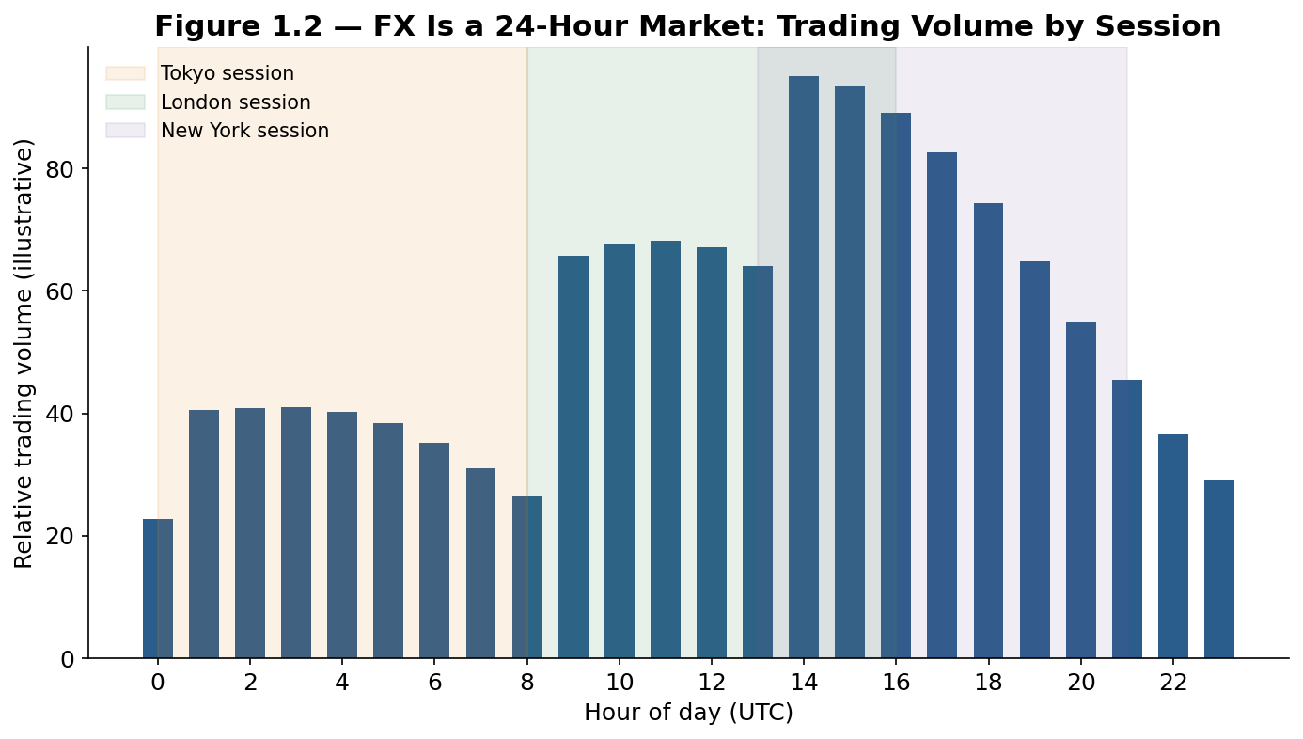
Figure 1.2 — FX trading volume rises and falls with the overlapping business hours of the major regional sessions, peaking during the London/New York overlap in the afternoon UTC, when liquidity across the whole market is typically deepest.
Tip — A pip ("percentage in point") is the standard unit of price movement quoted in FX — the fourth decimal place (0.0001) for most pairs, or the second decimal place (0.01) for pairs involving the Japanese yen. A move from 1.0850 to 1.0900 in EUR/USD is a 50-pip move. Because a pip represents a genuinely tiny price change, FX positions are typically traded in large notional sizes (a "standard lot" is conventionally 100,000 units of the base currency) to generate a meaningful dollar profit or loss from realistic daily moves.

1.2 Who Trades FX, and Why
The FX market's roughly $7.5 trillion in average daily turnover (per the Bank for International Settlements' regular Triennial Survey) is driven by a genuinely diverse set of participants with very different motivations, which is itself an important reason FX behaves differently from a market dominated mainly by return-seeking speculators:
- Commercial corporations — Multinational companies converting foreign sales revenue back to their home currency, or hedging the future cost of foreign purchases, trade FX as an unavoidable operational necessity rather than as a return-seeking bet (Part 5.1 covers this in depth).
- Central banks and sovereign wealth funds — Managing foreign exchange reserves, implementing monetary policy, and in some cases directly intervening in currency markets to influence the exchange rate (Part 4.4).
- Commercial and investment banks — Acting as market makers, providing the liquidity that allows other participants to trade, and running proprietary and client-facilitation trading books.
- Institutional investors — Pension funds, insurers, and asset managers converting currency to buy foreign stocks and bonds, and hedging the currency risk embedded in their existing foreign holdings.
- Hedge funds and systematic traders — Running the carry, momentum, and value strategies covered in Part 4, seeking to profit from currency movements directly.
- Retail traders — Individual speculators trading through retail FX brokers, a comparatively small share of total volume but a large share of public attention on the asset class.
This mix matters because a large share of FX's daily volume comes from participants who are trading for reasons entirely unrelated to a view on where the currency is headed — a corporation converting revenue does not care whether the currency is "cheap" or "expensive," it simply needs to convert it — which is one reason FX prices can display persistent patterns (like the carry trade's historical excess return) that would be arbitraged away more quickly in a market composed entirely of return-seeking speculators.

1.3 Spot Trades and the Mechanics of Settlement
The most basic FX transaction is a spot trade: an agreement to exchange two currencies at the currently quoted rate, conventionally settled two business days after the trade date (denoted "T+2"), reflecting the operational time historically needed to arrange the actual transfer of funds through the banking system in both currencies' home countries. This settlement convention, while it predates modern electronic payment systems, remains the market standard and underlies the pricing of every forward contract covered in Part 3, since a forward is priced relative to what a spot trade settled today would cost, adjusted for the interest rate differential over the period until the forward's own settlement date.
Worked example — A US-based importer agrees today to buy €1,000,000 worth of goods from a European supplier, with payment due in two business days. At a spot rate of EUR/USD 1.0850, the importer will need $1,085,000 to complete the purchase. If, instead, payment were due in three months, the importer would face exchange rate risk: the euro could strengthen or weaken against the dollar before payment is due, changing the effective dollar cost of the same €1,000,000 — precisely the risk that a forward contract, covered in Part 3.1, is designed to eliminate.

Part 2 — FX Pricing: Parity Conditions and Fair Value
Part 2 covers the core theoretical relationships that anchor FX pricing: purchasing power parity, which governs the very long run, and interest rate parity, which governs the pricing of forwards almost exactly at every moment. The gap between what these theories predict and what is actually observed is, not coincidentally, the origin of one of the most important systematic trading strategies in the module: the carry trade.

2.1 Purchasing Power Parity
Purchasing power parity (PPP) is the theory that, in the long run, exchange rates should adjust so that an identical basket of goods costs the same amount in any country once converted into a common currency. If a basket of goods costs $100 in the United States and the same basket costs €92 in the eurozone, PPP implies a "fair value" exchange rate of EUR/USD 1.0870 (100 / 92) — if the actual rate differs meaningfully from this, PPP predicts the exchange rate should eventually move to close the gap, as goods flow from the cheaper country to the more expensive one (in principle) and, more realistically, as relative inflation rates and capital flows gradually re-align prices.
S = P_domestic / P_foreign (the PPP "fair value" exchange rate, in domestic currency per unit of foreign currency)
The most famous popular illustration of PPP is The Economist magazine's Big Mac Index, which compares the price of an identical McDonald's Big Mac hamburger across countries, converted to a common currency, as a simple, deliberately light-hearted proxy for a much broader consumer price basket. The core insight generalizes well beyond hamburgers: comparing a broad, standardized basket of goods and services across countries gives an estimate of whether a currency looks cheap or expensive relative to its long-run PPP fair value.
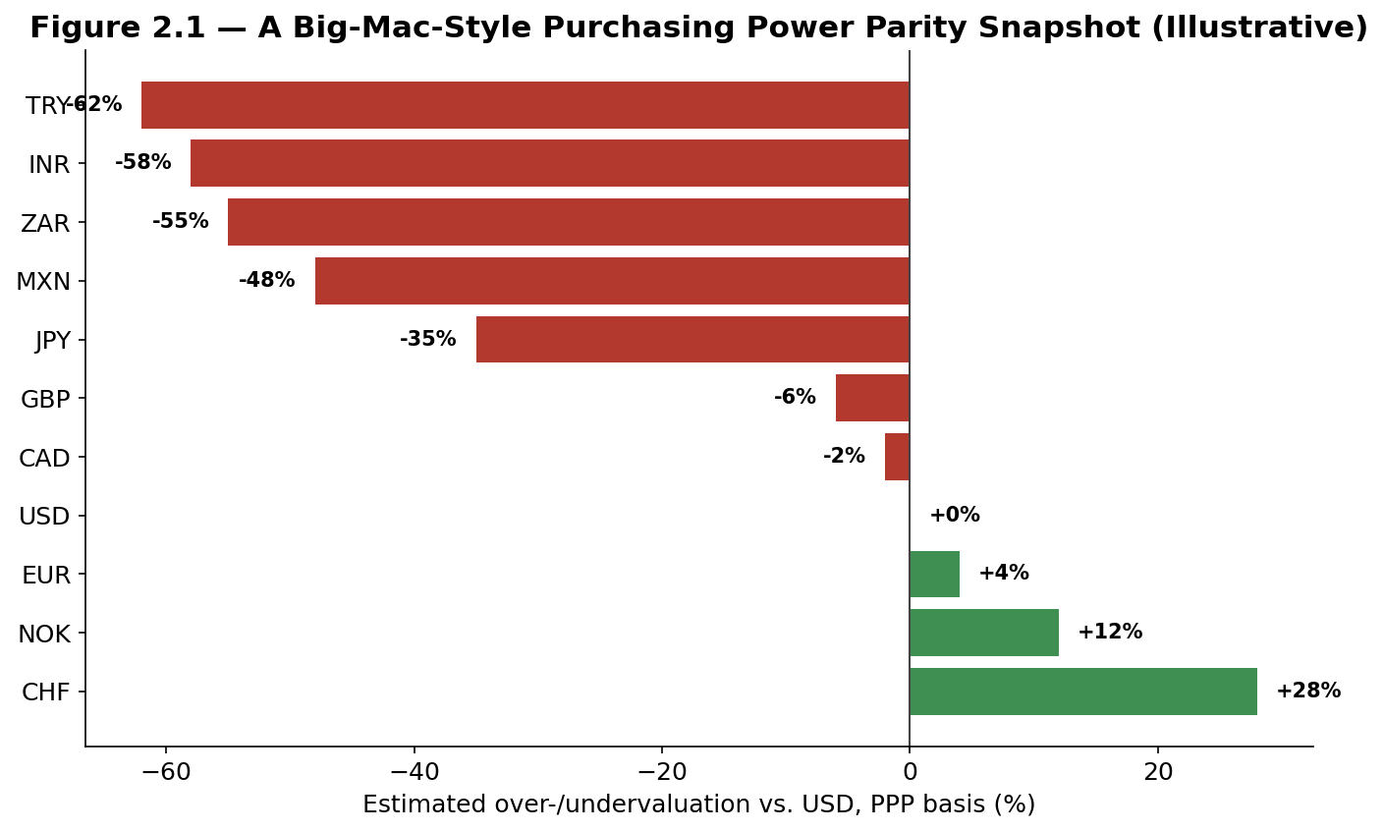
Figure 2.1 — A stylized purchasing-power-parity snapshot in the spirit of the Big Mac Index: currencies like the Swiss franc and Norwegian krone screen as persistently expensive on a PPP basis, while currencies like the Turkish lira, Indian rupee, and South African rand screen as persistently cheap — patterns that have, in fact, been observed for extended periods in real PPP comparisons.
Tip — PPP is a poor predictor of exchange rates over any horizon shorter than several years, and deviations from PPP fair value can persist for a decade or more without correcting. It is best understood as a long-run anchor and a useful cross-country valuation signal (feeding directly into the value strategies covered in Part 4.3), not as a short-term trading rule — a currency that looks "cheap" on a PPP basis can keep getting cheaper for years before, if ever, reverting.

2.2 Interest Rate Parity and Forward Pricing
Where PPP describes a loose, long-run tendency, interest rate parity is a precise, almost mechanical no-arbitrage relationship that links a currency pair's spot rate, its forward rate, and the two countries' interest rates. Covered interest rate parity (CIP) states that the forward exchange rate must be set so that borrowing in one currency, converting to the other at spot, investing at the foreign risk-free rate, and converting back at the forward rate yields exactly the same return as simply investing in the domestic risk-free rate — if it did not, an arbitrageur could lock in a riskless profit using only spot and forward contracts, with no exposure to which way the currency actually moves.
F = S × (1 + i_domestic) / (1 + i_foreign) (covered interest rate parity)
Here F is the forward rate, S is the spot rate, and i_domestic and i_foreign are the two currencies' interest rates over the forward's maturity. Because this relationship is enforced by pure arbitrage rather than by investor risk appetite or economic fundamentals, covered interest rate parity holds almost exactly in liquid, well-functioning markets, with only tiny, fleeting deviations reflecting transaction costs and funding frictions — deviations that became a subject of intense study after they widened unusually during the 2008 financial crisis, when bank funding stress temporarily impaired the arbitrage mechanism itself.
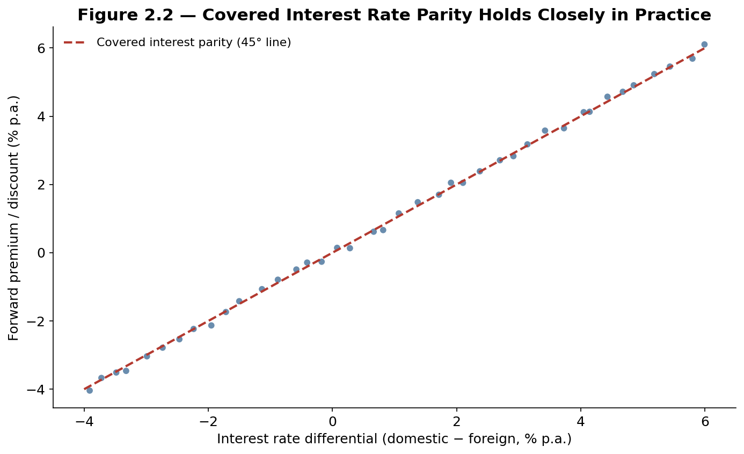
Figure 2.2 — Covered interest rate parity in action: across a range of simulated interest rate differentials, the market-implied forward premium or discount tracks the 45-degree no-arbitrage line almost exactly, reflecting how tightly this relationship is enforced by arbitrage in practice.
Uncovered interest rate parity (UIP) makes a related but economically very different claim: it predicts that a currency with a higher interest rate should be expected to depreciate by roughly the interest rate differential, so that an investor gains nothing, on average, from simply holding the higher-yielding currency unhedged rather than the lower-yielding one. Unlike covered interest rate parity, UIP is not enforced by pure arbitrage — it is a hypothesis about investor expectations and risk premia — and it is one of the most thoroughly falsified relationships in empirical international finance.
Worked example — Suppose the one-year interest rate is 5% in Australia and 1% in Japan, and the AUD/JPY spot rate is 95.00. Covered interest rate parity implies a one-year forward rate of approximately 95.00 × (1.01 / 1.05) ≈ 91.38 — the Australian dollar trades at a forward discount against the yen, exactly offsetting its interest rate advantage, so that a fully hedged investor earns the same return in either currency. Uncovered interest rate parity predicts that the spot AUD/JPY rate should, on average, actually fall to around 91.38 over the coming year, as the market's expectation of depreciation. Empirically, over many historical periods the Australian dollar has not depreciated by anywhere near this amount on average — which is precisely the gap that the carry trade, covered next, is built to exploit.

2.3 The Carry Trade: Trading the Deviation from UIP
The carry trade is arguably the single most studied systematic strategy in all of foreign exchange: borrow in a low-interest-rate funding currency, convert the proceeds into a high-interest-rate target currency, and invest at the higher rate — earning the interest rate differential as long as the target currency does not depreciate by more than that differential before the position is unwound. If uncovered interest rate parity held exactly, this strategy would earn zero expected excess return, since any interest rate advantage would be offset, on average, by the target currency's expected depreciation. The historically documented fact that carry trades have earned a positive average excess return over long periods, across many different currency pairs and time periods, is known in the academic literature as the forward premium puzzle or the UIP puzzle, and is one of the most extensively researched anomalies in international finance.
Carry return ≈ (i_target − i_funding) − ΔS/S (interest differential minus the target currency's depreciation)
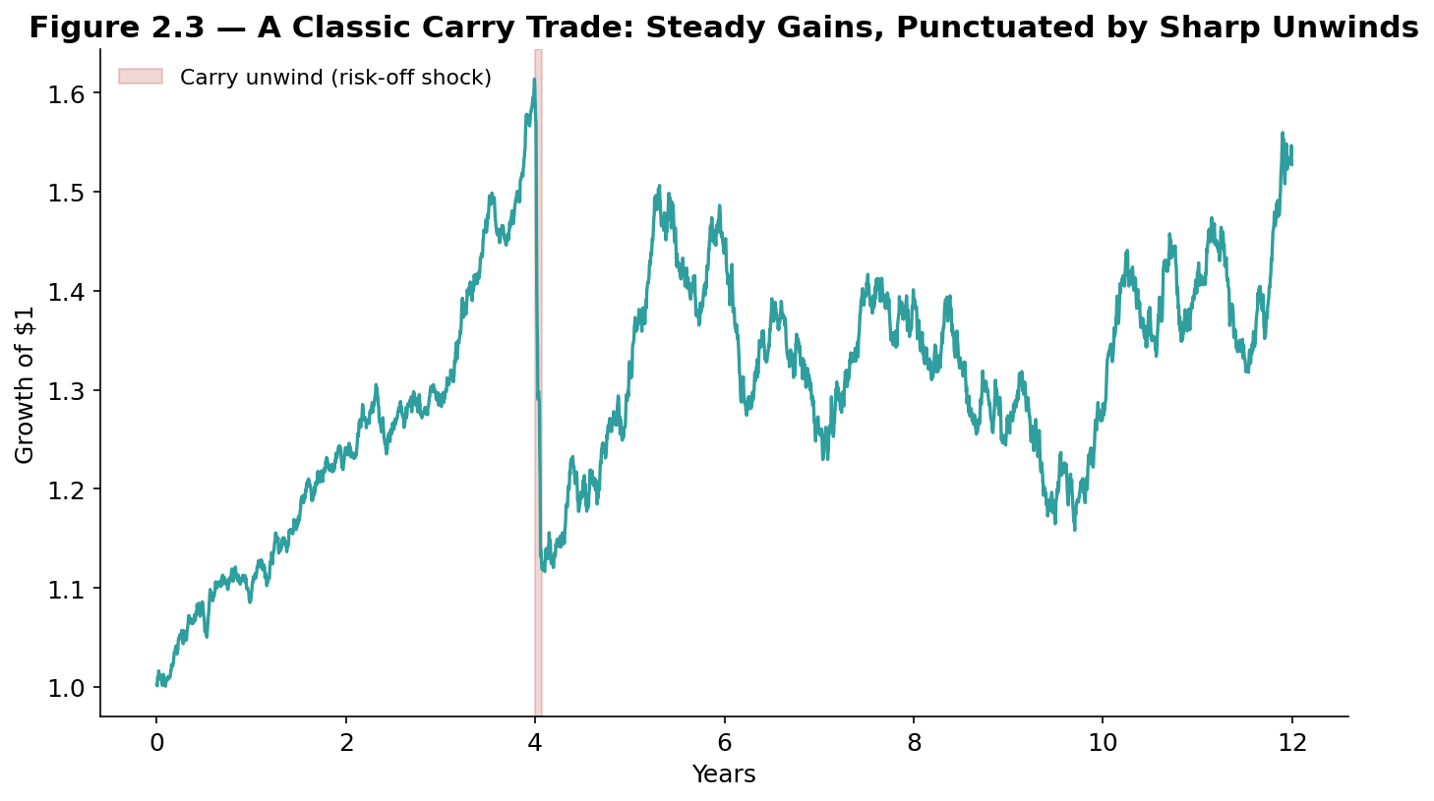
Figure 2.3 — The classic carry-trade signature: a long stretch of small, steady gains from the interest rate differential, followed by a sudden, sharp loss when a risk-off shock triggers a rapid, crowded unwind — a pattern repeatedly observed in real carry trades, most famously in the second half of 2008.
The classic real-world illustration is the yen carry trade: for much of the 2000s and again in the 2010s and early 2020s, Japan maintained interest rates near zero while many other economies (Australia, New Zealand, and at times emerging markets) offered materially higher rates, making the Japanese yen a persistent, heavily used funding currency. The most dramatic historical unwind of the yen carry trade came during the second half of 2008, when the global financial crisis triggered a sharp "risk-off" shift: investors rushed to unwind leveraged carry positions simultaneously, causing the yen to appreciate sharply and abruptly against nearly every major currency in a matter of weeks, inflicting large, correlated losses on carry traders regardless of which specific target currency they had used — a pattern strikingly similar to the crowded-unwind dynamics covered in the Statistical Arbitrage module's treatment of the August 2007 quant quake.
Common mistake — Treating the carry trade's historically positive average return as evidence that it is a low-risk strategy. The excess return compensates for a real and specific risk: carry trades tend to lose money precisely when global risk appetite deteriorates sharply (a pattern sometimes summarized as carry having a payoff profile similar to "picking up nickels in front of a steamroller") — meaning the strategy's losses are concentrated in exactly the market environments where an investor's other holdings are also likely to be performing badly, which is a much less attractive risk profile than the same average return earned steadily and independently of broader market conditions.

Part 3 — FX Derivatives: Forwards, Futures, Swaps, and Options
Part 3 covers the four main derivative instruments used to trade or hedge currency risk beyond a simple spot transaction: outright forwards and FX swaps, exchange-traded currency futures, and FX options, ending with the distinctive shape of implied volatility in the FX options market.

3.1 Outright Forwards and FX Swaps
An outright forward is a contract to exchange two currencies at a rate agreed today, for settlement on a specified future date beyond the standard two-day spot settlement — exactly the instrument the importer in Part 1.3's worked example would use to lock in a rate for a payment due in three months, priced using the covered interest rate parity formula from Part 2.2. An FX swap combines a spot transaction with an offsetting forward transaction in the opposite direction — for example, buying euros for dollars today while simultaneously agreeing to sell those euros back for dollars in three months. FX swaps are used overwhelmingly for short-term funding and liquidity management rather than speculation: a bank that needs euros for a few months but does not want to take on open-ended currency risk can use a swap to borrow effectively in euros while posting dollars as the economic equivalent of collateral, and by traded volume FX swaps are actually the single largest instrument category in the entire FX market, larger than spot trading itself.
Tip — It is easy to confuse an FX swap with a currency swap. An FX swap is a short-term instrument, typically maturing in under a year, that exchanges principal at both the start and end of the contract with no periodic interest payments in between. A currency swap is a longer-term instrument, often maturing in several years, that additionally exchanges periodic interest payments in each currency over the life of the contract — a materially different and more complex instrument despite the similar name.

3.2 Currency Futures and Non-Deliverable Forwards
Currency futures are standardized, exchange-traded versions of a forward contract — most notably traded on the CME (Chicago Mercantile Exchange) — offering the same basic economic exposure as an outright forward but with the added benefits of centralized clearing (removing counterparty credit risk), daily mark-to-market settlement, and standardized contract sizes and expiration dates that make them easy to trade anonymously on an exchange rather than negotiating bilaterally with a bank.
For currencies subject to capital controls or limited convertibility — the Chinese renminbi (in its offshore form), the Indian rupee, and the Brazilian real are common examples — a standard deliverable forward is often impractical or restricted. The market has developed the non-deliverable forward (NDF) to address this: instead of physically exchanging the two currencies at maturity, an NDF settles in cash, in a fully convertible currency (typically US dollars), based purely on the difference between the contracted forward rate and the prevailing spot rate on the settlement date. NDFs allow international investors and corporations to hedge or take a view on restricted currencies without ever needing to hold or transfer the underlying, restricted currency itself.

3.3 FX Options and the Volatility Smile
An FX option gives its holder the right, but not the obligation, to exchange currency at a specified rate (the strike) on or before a specified date, priced using a version of the same Black-Scholes-family framework used for equity options, adapted to account for the fact that both currencies in the pair earn their own risk-free interest rate (the Garman-Kohlhagen model). A distinctive feature of the FX options market, shared with equity options but with a distinctly different shape, is that implied volatility is not constant across strikes for a given expiration — it varies in a pattern known as the volatility smile.
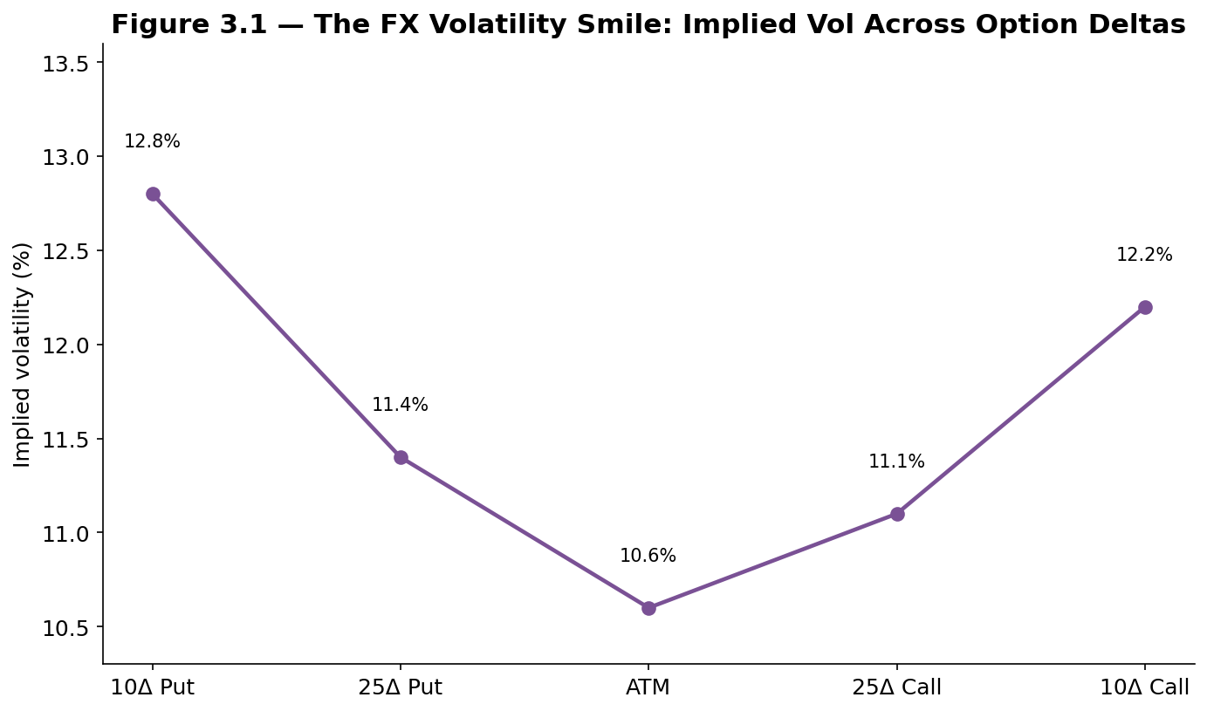
Figure 3.1 — The FX volatility smile: implied volatility is typically lowest for at-the-money options and rises for both out-of-the-money puts and out-of-the-money calls, reflecting the market's pricing of a higher probability of a large move in either direction than a simple constant-volatility model would predict.
The FX options market conventionally quotes volatility not by strike price but by delta — the option's sensitivity to the underlying spot rate — because delta remains stable and comparable as the spot rate moves, while a fixed strike's "moneyness" changes constantly. The standard quoted structure covers the at-the-money (ATM) volatility, the 25-delta risk reversal (the volatility difference between a 25-delta call and a 25-delta put, a direct measure of skew — whether the market prices a bigger risk of a large move up or a large move down), and the 25-delta butterfly (a measure of how much more expensive the wings of the smile are than the at-the-money point, a direct measure of the curvature of the smile itself). A currency pair's risk reversal is one of the most closely watched real-time market signals of sentiment: for example, the yen's risk reversals tend to shift sharply toward pricing a higher probability of yen strength (a positive risk reversal favoring yen calls, from a dollar-based perspective) during periods of market stress, directly reflecting its role as a safe-haven currency, discussed further in Part 5.2.
Worked example — A three-month EUR/USD at-the-money option might trade at 10.6% implied volatility, while the 25-delta put trades at 11.4% and the 25-delta call trades at 11.1% — a risk reversal of roughly 0.3 volatility points in favor of puts, indicating the options market is pricing a slightly higher probability of a sharp euro depreciation than an equally-sized euro appreciation over the period. A trader with a view that this skew is too extreme, relative to their own assessment of the balance of risks, could sell the relatively expensive put and buy the relatively cheap call in a risk reversal trade, directly expressing a view on the shape of the smile rather than on the direction of the spot rate itself.

Part 4 — Trading and Investment Strategies in FX
Part 4 surveys the major systematic strategy families run in currency markets today, several of which connect directly to strategy families covered elsewhere in this curriculum, and closes with a detailed look at event-driven FX — the central bank actions, currency pegs, and financial crises that have repeatedly produced the sharpest, most consequential moves in the entire asset class.

4.1 Carry Strategies in Practice
Building on Part 2.3, a practical, diversified carry strategy does not simply pick a single currency pair but ranks a broad basket of currencies by their interest rates, going long the highest-yielding currencies and short the lowest-yielding ones, rebalanced periodically — directly analogous to the cross-sectional strategy construction covered in the Factor Models module's treatment of the Fama-French factors. This diversified construction reduces (though does not eliminate) the strategy's exposure to any single currency's idiosyncratic risk, while still capturing the broad, persistent tendency for higher-yielding currencies to outperform lower-yielding ones on average.
A well-known refinement, sometimes called carry-to-risk or volatility-adjusted carry, sizes each currency's position not just by its interest rate but by its interest rate relative to its own volatility — recognizing that a currency with a high interest rate but also very high volatility offers a much less attractive risk-adjusted carry opportunity than a currency with a somewhat lower rate but much greater stability.

4.2 Momentum and Trend-Following
FX momentum (or trend-following) strategies bet that a currency's recent directional trend — typically measured over the trailing several months to a year — will continue in the near term, buying currencies that have been appreciating and selling those that have been depreciating. Trend-following in FX has a particularly long practical history, forming a core strategy for many of the earliest systematic "managed futures" trading firms dating back to the 1970s and 1980s, and academic research has documented momentum as a statistically robust pattern in currency returns across multiple decades and many different currency pairs.
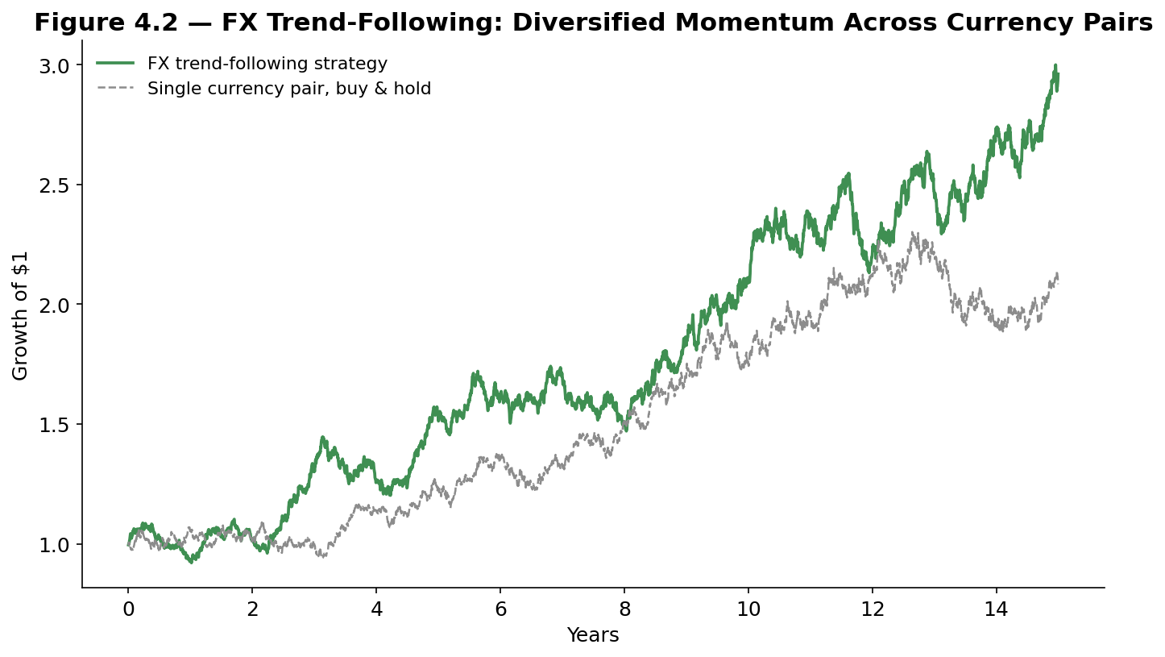
Figure 4.2 — A diversified FX trend-following strategy, trading momentum across many currency pairs simultaneously, tends to produce a smoother, more consistent equity curve than any single currency pair traded on its own, which typically wanders without a strong long-run directional bias.
The most commonly cited economic explanation for FX momentum overlaps partly with the carry trade itself: because central banks tend to move interest rates gradually rather than all at once, a currency that has started appreciating due to a hawkish (rate-raising) central bank often continues to appreciate as the central bank continues raising rates over the following months, giving trend-following strategies a structural tailwind that is closely, though not perfectly, related to the carry trade's interest-rate-driven logic.

4.3 Value and Mean-Reversion Strategies
FX value strategies flip the momentum logic around, using the purchasing power parity framework from Part 2.1 directly as a trading signal: buy currencies that appear significantly undervalued relative to their PPP fair value, and sell currencies that appear significantly overvalued, on the premise that very large PPP deviations tend to correct over sufficiently long horizons (typically several years, in contrast to the much shorter horizons used for carry and momentum). Because PPP deviations can persist for years before correcting, value strategies in FX are generally implemented with a long holding period and modest position sizing relative to how large the apparent mispricing looks, precisely because Part 2.1 already established that PPP is a poor short-term timing signal.
Tip — Carry, momentum, and value in FX are not fully independent of one another, and in practice their signals often conflict: a currency can simultaneously look cheap on a PPP basis (a value buy signal), be in a sustained downtrend (a momentum sell signal), and offer a low interest rate (a carry sell signal). Many institutional systematic FX programs blend all three signals into a single combined score, precisely because each signal's weaknesses (momentum's vulnerability to sharp reversals, value's long and uncertain timing, carry's crash risk) are at least partially independent of the others' weaknesses.

4.4 Event-Driven FX: Central Banks, Pegs, and Crises
Some of the largest and most consequential moves in FX history have come not from the gradual operation of carry, momentum, or value, but from a sudden change in government or central bank policy. This module highlights four of the most instructive real-world episodes:
- Black Wednesday (16 September 1992) — The United Kingdom was forced out of the European Exchange Rate Mechanism (ERM), a precursor system to the euro that required the pound to be held within a narrow band against other European currencies, after speculative selling pressure — most famously associated with George Soros's Quantum Fund — overwhelmed the Bank of England's attempts to defend the pound through interest rate increases and direct market intervention, forcing a large, disorderly devaluation in a single day.
- The Asian Financial Crisis (1997–98) — Several Southeast Asian currencies, including the Thai baht, Indonesian rupiah, and South Korean won, had maintained pegs or tightly managed rates against the US dollar; as capital flowed out amid concerns over current account deficits and over-leveraged banking systems, these pegs collapsed in rapid succession, triggering sharp devaluations, contagion across the region, and ultimately International Monetary Fund intervention in several affected economies.
- The Swiss National Bank's CHF Shock (15 January 2015) — The SNB had held a floor of 1.20 EUR/CHF since 2011, committing to intervene without limit to prevent the franc from strengthening beyond that level. On 15 January 2015, with essentially no advance warning, the SNB abruptly removed the floor; the franc surged roughly 30% against the euro within minutes, inflicting severe losses on retail brokers, corporations, and leveraged currency traders caught on the wrong side, and became the canonical modern example of the risk that a currency peg can be maintained for years and then abandoned essentially overnight.
- COVID-19 Dollar Liquidity Squeeze (March 2020) — As global markets sold off sharply in the early weeks of the pandemic, the US dollar experienced a sudden, sharp appreciation against nearly every other currency — not primarily because of a change in US economic fundamentals, but because of an acute global scramble for dollar liquidity to meet margin calls and refinance dollar-denominated debt, a dynamic ultimately addressed by the US Federal Reserve's rapid expansion of dollar swap lines with other major central banks.
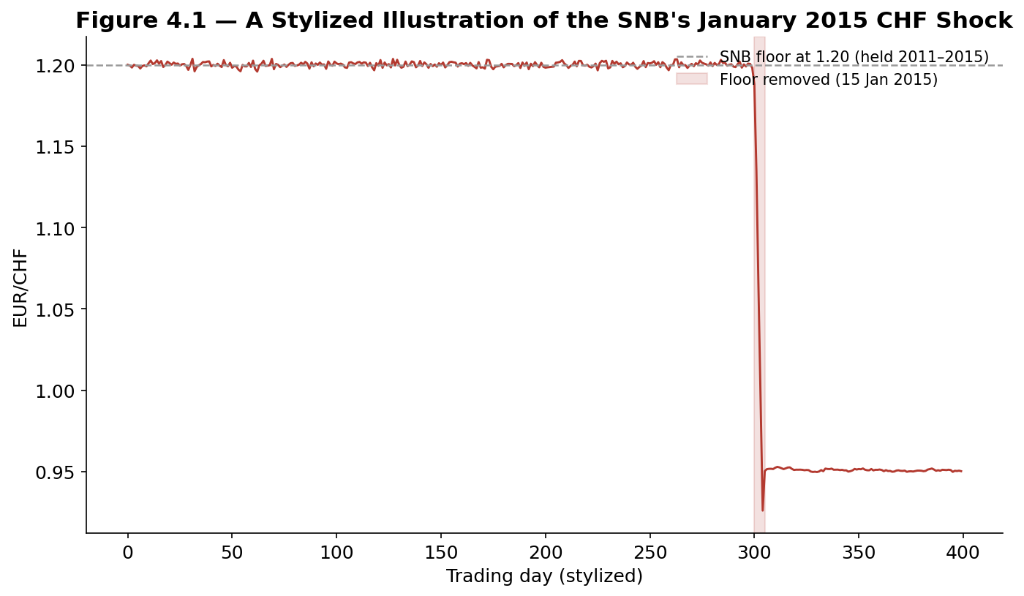
Figure 4.1 — A stylized illustration of the SNB's January 2015 shock: EUR/CHF traded in an extremely tight band around the 1.20 floor for years, then gapped violently within minutes of the floor's removal — the clearest real-world illustration in this module of the prerequisite gate's warning that a pegged rate is a policy choice, not a law of markets.
Each of these four episodes shares a common structural lesson directly relevant to the pricing theory covered in Part 2: purchasing power parity and interest rate parity describe how a currency should trade absent policy intervention, but a government or central bank actively defending a specific rate can hold the currency away from that level for a long time — right up until the moment it cannot, or chooses not to, anymore.

Part 5 — Risk Management and Practical Considerations
The final part turns from pricing theory and strategy design to the practical discipline of managing currency risk: how corporations and portfolio managers hedge unwanted FX exposure, how volatility and skew are used to price and monitor tail risk, and the recurring pitfalls — crowded trades, sudden flash events, and regime change — that have produced FX's most severe historical losses.

5.1 Hedging FX Exposure
For a multinational corporation or an international investor, FX exposure is frequently an unwanted byproduct of an otherwise unrelated business or investment decision, and the most common use of the derivative instruments covered in Part 3 is not speculation but hedging — deliberately taking an offsetting position to neutralize that exposure. A US company expecting to receive €10 million in three months from a European customer can sell euros forward today at a locked-in rate, eliminating the risk that the euro weakens before payment arrives (at the cost of also giving up any benefit if the euro instead strengthens); an international bond investor can hedge the currency risk of a foreign bond holding with a rolling series of short-dated forwards, isolating the bond's own interest-rate and credit exposure from unwanted currency risk.
- Transaction exposure — Risk from a specific, contracted future cash flow in a foreign currency (the importer and exporter examples above), typically hedged with a matched forward or option.
- Translation exposure — The accounting risk that a multinational company's foreign subsidiary's assets and earnings, when translated back into the parent company's reporting currency, change in value purely due to exchange rate movements, without any underlying change in the foreign business itself.
- Economic exposure — The broader, harder-to-hedge risk that a company's competitive position or future cash flows are affected by exchange rate movements over the long run — for example, a US manufacturer competing against European rivals becoming structurally less price-competitive if the dollar strengthens persistently, a risk that cannot be fully addressed with any single forward or option contract.
Tip — A hedge is, by design, intended to reduce risk, not to generate profit — a company that hedges its currency exposure and then sees the currency move in its favor has, correctly, given up the currency gain in exchange for having removed the currency loss scenario before the outcome was known. Evaluating a hedging program by whether the hedge "made money" in hindsight, rather than by whether it reduced the variability of outcomes as intended, is a common and avoidable source of confusion for newcomers to corporate FX risk management.

5.2 Volatility, Skew, and Tail Risk
FX volatility is not uniform across currency pairs or through time. Major, freely floating pairs among large, stable economies (EUR/USD, USD/JPY) typically exhibit lower volatility than emerging-market pairs, which are more exposed to sudden capital flow reversals, political risk, and — as the Asian Financial Crisis illustrated — the risk of an outright currency peg collapsing. Volatility also rises sharply and predictably around known event risk: central bank policy meetings, major economic data releases, and elections all reliably show elevated implied volatility in the options market in the days beforehand, reflecting the market's anticipation of a potentially large move.
The volatility smile and risk reversal covered in Part 3.3 are also a direct, continuously updated market signal of perceived tail risk. During periods of acute market stress, risk reversals across many currency pairs typically shift sharply toward pricing a higher probability of moves into traditional safe-haven currencies — the US dollar, Japanese yen, and Swiss franc — reflecting the same flight-to-safety dynamic that drove the dollar's sharp appreciation during the March 2020 COVID-19 shock described in Part 4.4.
Worked example — In the days immediately before a highly anticipated central bank interest rate decision, one-week implied volatility on the relevant currency pair might jump from a typical 7% to 14% or higher, even though the actual historical (realized) volatility over the preceding weeks was calm — the options market is pricing in the specific, known risk of the announcement itself, a pattern that then typically collapses back toward normal levels immediately after the decision is announced and the uncertainty resolves, an effect commonly referred to as an implied volatility crush.

5.3 Pitfalls: Crowded Carry Trades, Flash Events, and Regime Change
Three recurring risks account for the majority of FX's most severe historical losses, echoing themes introduced in both the Factor Models and Statistical Arbitrage modules but taking a distinctly FX-specific form.
- Crowded carry trades — As covered in Part 2.3, when a large amount of leveraged capital is positioned in the same carry trade (long the same target currencies, short the same funding currency, most famously the yen), a shift in global risk sentiment can trigger a rapid, self-reinforcing unwind as many participants try to close similar positions simultaneously, causing the funding currency to appreciate far more sharply and abruptly than ordinary volatility would suggest.
- Flash events and peg breaks — The SNB shock and the Asian Financial Crisis both illustrate a distinct risk from ordinary market volatility: a sudden, discontinuous repricing driven by a policy decision rather than a gradual shift in market sentiment, against which standard risk models calibrated on historical day-to-day volatility offer very limited protection, since the entire point of such an event is that it does not resemble the recent historical pattern the model was calibrated on.
- Regime change in the underlying relationships themselves — A currency's historical correlation with risk sentiment, its typical volatility regime, or even its exchange rate framework (fixed, managed, or floating) can change permanently — a country can abandon a peg, join a currency union, or shift its central bank's policy framework entirely, invalidating historical relationships that a model or strategy may have been built on without realizing the ground had shifted.
Common mistake — Sizing a carry trade or any other systematic FX strategy based only on its historical volatility, without separately asking how much capital across the industry is likely positioned in the same direction. As with crowded statistical arbitrage trades, a currency strategy's own historical return series typically gives very little advance warning of a crowding-driven unwind, precisely because such events are driven by other market participants' aggregate positioning rather than by anything visible in one trader's own historical data.

Practical Exercise
Choose three currency pairs, each involving a different funding/target currency combination (for example, a low-yield major such as JPY or CHF against two different higher-yield currencies). For each pair, gather at least five years of daily spot data and the corresponding short-term interest rates for both currencies, then work through the checklist below before drawing any conclusions about the carry trade's performance.

FX strategy validation checklist
- Compute the realized carry return — using the formula from Part 2.3, decompose each pair's total return into the interest rate differential component and the spot price change component separately.
- Identify the largest historical drawdown — and check whether it coincides with a known risk-off period (2008, March 2020, or another documented episode) rather than assuming drawdowns are randomly distributed through time.
- Test combining carry with a trend filter — for example, only holding a carry position when the target currency is not in a strong downtrend, and compare the resulting risk-adjusted return to the unfiltered carry strategy.
- Check volatility-adjusted position sizing — scale each currency pair's position by its trailing volatility rather than using equal notional sizing, and compare the resulting portfolio's Sharpe ratio and maximum drawdown.
- Stress test against a known event — apply the actual percentage move from the SNB shock or a comparable historical event to your current position sizes, and confirm the resulting hypothetical loss would be survivable under your risk limits.
# Skeleton for the practical exercise

def decompose_carry_return(spot, rate_domestic, rate_foreign, dt=1/252):
fx_return = spot.pct_change()
carry_component = (rate_domestic - rate_foreign) * dt
total_return = carry_component + fx_return
return carry_component, fx_return, total_return

def trend_filtered_carry(total_return, spot, lookback=126):
trend = spot / spot.shift(lookback) - 1
# only hold the carry position when trend is not sharply negative
filtered_return = total_return.where(trend > -0.05, 0)
return filtered_return

# Evaluate: annualized return and volatility of raw vs. trend-filtered
# carry, maximum drawdown, and a written note on which historical
# risk-off events drove the largest losses in the raw strategy.

Common Beginner Mistakes
- Treating PPP as a short-term trading signal — buying a currency simply because it looks cheap on a PPP basis, without accounting for how many years a PPP deviation can persist before, if ever, correcting.
- Ignoring the difference between covered and uncovered interest rate parity — assuming that because CIP holds almost exactly, UIP must also hold, when the entire carry trade literature exists specifically because UIP does not.
- Assuming a currency peg is permanent — sizing a leveraged position against a pegged currency pair based on its historically near-zero volatility, without asking what would happen, and how it would be sized, the day the peg is removed.
- Evaluating a hedge by whether it made money — rather than by whether it successfully reduced the variability of outcomes, which is what a hedge is actually designed to do.
- Ignoring carry trade crowding — assuming the carry trade's long-run average historical return applies equally in every period, regardless of how much leveraged capital is currently positioned in the same trade.

Advanced Extensions
The following are Level 3–5 topics, introduced here only by name so you know what to look for when you reach them:
- Term structure of FX forwards and cross-currency basis — modeling the full curve of forward points across maturities, and the persistent deviations from covered interest rate parity (the cross-currency basis) that have been observed in major currencies since the 2008 financial crisis.
- Stochastic volatility and jump-diffusion models for FX options — extending the Garman-Kohlhagen framework from Part 3.3 to models that can better capture the volatility smile and the risk of sudden, discontinuous moves such as the SNB shock.
- Machine-learning-based multi-factor FX models — combining carry, momentum, value, and volatility signals using modern statistical learning techniques, extending the simple signal-blending approach described in Part 4.3.

Professional Applications
- Corporate treasury departments — Multinational companies run systematic hedging programs using the forwards and options covered in Part 3 to manage the transaction, translation, and economic exposures described in Part 5.1 as a routine part of financial management.
- Global macro and systematic FX hedge funds — Firms running the carry, momentum, and value strategies covered in Part 4, often blended into a single systematic program and traded across dozens of currency pairs simultaneously.
- Central banks and sovereign reserve managers — Directly shape the market through the interest rate policy underlying interest rate parity, and through the direct intervention and peg-management actions covered in Part 4.4.

Where to Go Next
This module covered foreign exchange from basic market mechanics through purchasing power parity and interest rate parity, the major FX derivative instruments, the carry, momentum, and value strategy families, and the real-world crises and risk-management practices that govern how currency risk is actually handled in practice. The Statistical Arbitrage module's Part 2 and Part 5 cover the mean-reversion and crowding concepts this module applies specifically to currencies; the Factor Models module's Part 3 covers the broader cross-asset factor framework that carry and momentum in FX are a specific instance of; and the Risk Metrics module builds on this module's Part 5 to cover portfolio-level currency risk measurement, including value-at-risk approaches to the tail risks introduced here.

